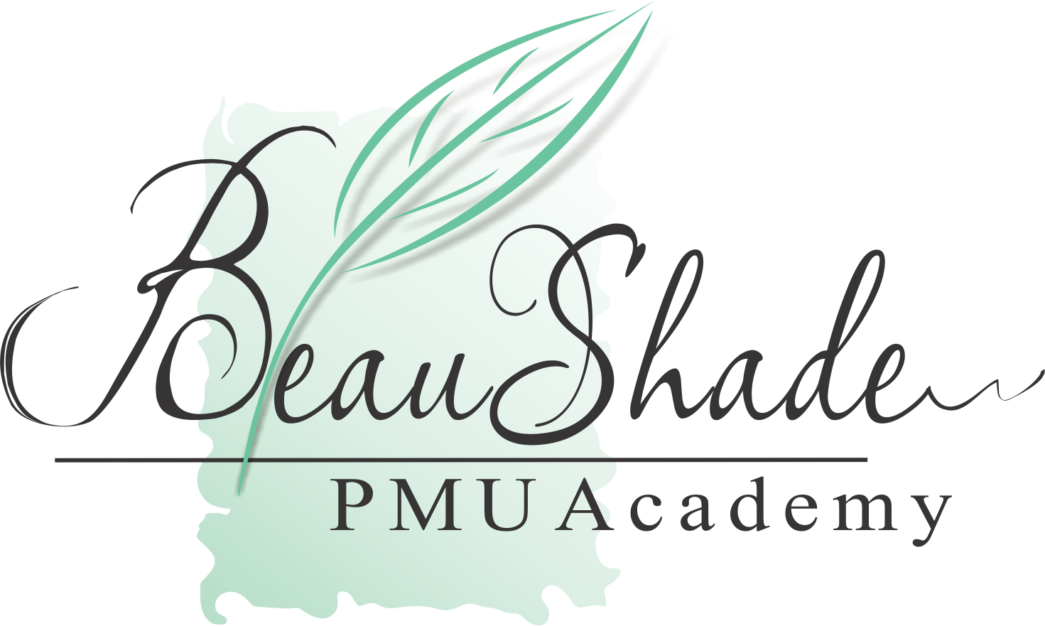BB-Glow Test

- For the Certificate application please provide your personal details:
Given Name ____________________
Middle Name __________________
Last Name _____________________

- Please reply to the questions below:
- Are there any differences between skin needling and BB-Glow?_______________________
- Are there any differences between cosmetic tattoo camouflage and BB-Glow?___________
- What cartridge should be used within the BB-Glow procedure? ______________________
- Which skin layer should the BB-glow serum be applied to? __________________________
- Is it possible to achieve a long lasting BB-glow effect after skin penetration? ____________
- How long does the epidermal renewal take for a 20 years old person? _________________
- Where is the melanin located? ________________________
- Can you work with the same machine settings through the whole procedure? __________
- Is it necessary to use any sun protection after the procedure? _______________________
- Is it possible to repeat BB-Glow procedure in a week after the previous session? ________

- Save this file along with your completed answers for assessment and send to the following email:
Pezina-a@yandex.ru
Upon successful completion you will be sent an electronic copy of your certificate by Beaushade PMU Academy.

